Aapka Store

Software Requirements Specification

Version 1.0



Group Id:
Student Name: Supervisor Name:

Revision History
Date (dd/mm/yyyy) | Version | Description | Author
14-07-2023 | 1.0 | Aapka Store

Table of Contents

- Scope (of the project)
- Functional Requirements Non Functional requirements
- Use Case Diagram
- Usage Scenarios
- Adopted Methodology
- Work Plan (Use MS Project to create Schedule/Work Plan)

SRS Document

- Scope of Project:

E-Commerce is helpful for both the customer and the businessmen. With the help of e-commerce, the customer can buy any of the desired products available online. The main advantage of buying the product online is that you just order it and it will be at your doorstep.
To facilitate the customer to buy products online, the businessmen need a website where he/she displays the products which he/she is offering to sell.
“AapkaStore” is a website that helps customers who intend to buy things online. Customers can easily navigate through the website and find the desired product category wise or individually. Product ordered through the website is delivered to the customer’s desired place.
The project is aimed to manage the details of Products, Sale, Stock, Purchase and Date Wise Sale. It also manages all information about the Vendors, Sales Man and its Reporting. The project is totally built at administrator and user end of things. Only the administrator is guaranteed to have full control on the application. It provides search facility such as searching for Stock, Products and Vendors/Company.
It stores all information about staff in a secure database. It also generates reports. We can add, delete and update, the records easily. It can generate Vendor report. It manages all information of Customer Record. We can easily generate Invoice and take print for Customer.

.

- Functional and Non-Functional Requirements:

Functional Requirements:

Following are the functional requirements, you have to fulfil for this project.

- Application should have following Interfaces. (i) User Registration (ii) Dashboard (iii) Stock Details (iv) Purchase Items (v) Sale Items Records (vi) Invoice Generation
(vii) Vendor Details (viii) Daily, Monthly and Annually Sale Report (ix) Stock Items Report
(x) Max sold out product List (xi) List of Items which are low in quantity or out of stock. (xii) Messaging feature to send order messages to customer number. (xiii) Customer/User must be able to give their comments against each product and give starts to rate the product. (xiv) You have to add a WhatsApp icon on website, which will allow users to click and start a conversation with us. (xv) Website must include About Us, Contact us and Privacy policy pages for customers. (xvi) You should create a single login form with options for both user and admin roles. There is no need to create a separate login form for admins and users.
(xvii) You must add a "forgot password" option to the login form. When a user clicks this option, the website will send a reset password email to the email address registered with the user's account.

- The proposed application should have two modules. Admin module and User module.

- Admin Module:
- Admin have access to control all components of application but user can access limited components of application. When the user or admin open the application using login credentials their username will be displayed on the dashboard.
- Admin can add the products into the stock.
- Admin can maintain the records of purchase items.
- Admin can generate and print the invoice of sale items and other reports.
- Whenever the admin adds any entry or generate invoice, entry will save in database with name of respective person.
- Admin can add and maintain the Vendors and Sales man records in database.

- User Module:

- User has access to visit the website and search and purchase any product of his/her choice and it must be necessary for user to create his account first before shopping on website.
- When user purchase any product from website it will be first added into cart and different payment method will be shown to user to buy product.
- Different menu product categories must be on website navigation bar like (Mobile Accessories, Garments, Plastic Sheets, Grocery items)
- User can contact to website admin through WhatsApp feature icon visible on home page of the website.
- User can give their feedback about any product by using comment feature and can rate the product.

Non-Functional Requirements:
The non-functional requirements show the following list of functionalities
These functionalities help the application.
Performance - Response Time, Throughput, Utilization, Static Volumetric
Usability: The system will be User Friendly.
Availability: The System will be available 24 hours.
Efficiency: The System will be efficient
Reliability: The System will be able to complete its on-going operations in spite of any error or problem within defined response time

- Use Case Diagram(s):

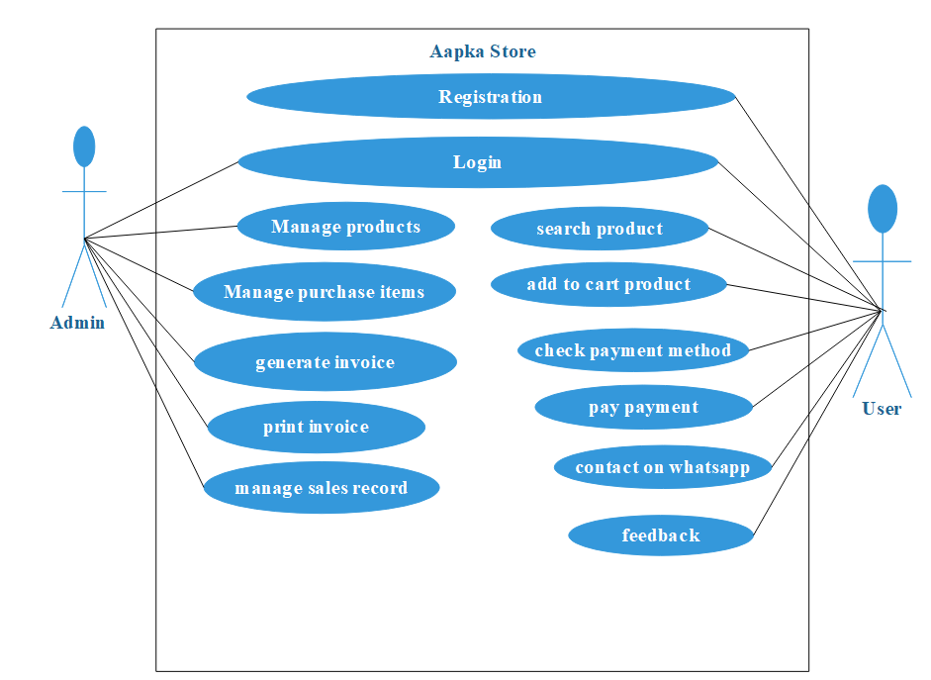

- Usage Scenarios:

Use Case Title | Registration
Use Case Id: UC: | 01
Requirement Id: | 01
Description: users can register into the system

Pre-Conditions: Application already open
Task Sequence |  | Exceptions
- user open registration form |  | User not registered
- user fill the registration form by entering his/her name, CNIC number, Cell number and then press save button
- Application saves users detail in database
Post Conditions: users’ registration successfully.
Unresolved issues: None
Authority: users
Author: ()
Description: version 1.0

Use Case Title | Log in
Use Case Id: UC: | 02
Requirement Id: | 02
Description: user can log in into the system
Pre-Conditions: Application already open
Task Sequence |  | Exceptions
- Application shows log in interface |  | User detail not verified
- user enter login detail username and password
- Application verified user detail from database
Post Conditions: user log in successfully.
Unresolved issues: None
Authority: users
Author: ()
Description: version 1.0

Use Case Title | Manage Products
Use Case Id: UC: | 03
Requirement Id: | 03
Description: Admin can manage products

Pre-Conditions: Application already open
Task Sequence |  | Exceptions
- Admin open manage products form. |  | products not managed
- Admin choose products detail to be added/deleted/updated then submit form.
- Application saves products detail in database
Post Conditions: Admin manage products detail successfully.
Unresolved issues: None
Authority: Admin
Author: ()
Description: version 1.0

Use Case Title | Manage purchase items
Use Case Id: UC: | 05
Requirement Id: | 05
Description: Admin can manage purchase items

Pre-Conditions: Application already open
Task Sequence |  | Exceptions
- Admin open manage purchase items form. |  | purchase items not managed
- Admin choose purchase items to be added/deleted/updated then submit form.
- Application saves purchase items records in database
Post Conditions: Admin manage purchase items successfully.
Unresolved issues: None
Authority: Admin
Author: ()
Description: version 1.0

- Adopted Methodology

“Methodology” is a frame work that is used to structure, plan and control the process of developing a software system
In the project we will use vu process modal which is the combination of water fall and spiral modal we will discuss both these models and then by the combination of these modal we will develop our methodology for our required project
Waterfall modal:
It is the best known and one of the oldest processes modals. It is a sequential design process steadily downwards through the phases of requirements, design, implementation, verification and maintenance. After each step is finished, the process proceeds to the next step.
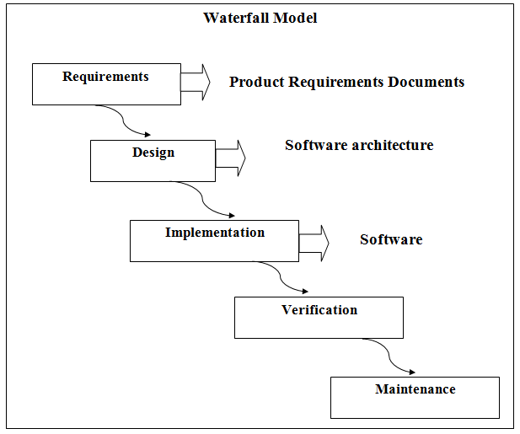

Next we will discuse spiral modal

Spiral Model:

The spiral model is based on the unique risk patterns and risk-driven process model generator for complicated, large and expensive projects. It guides a team to implement the elements of one or more process model such as, waterfall or prototyping and so on.

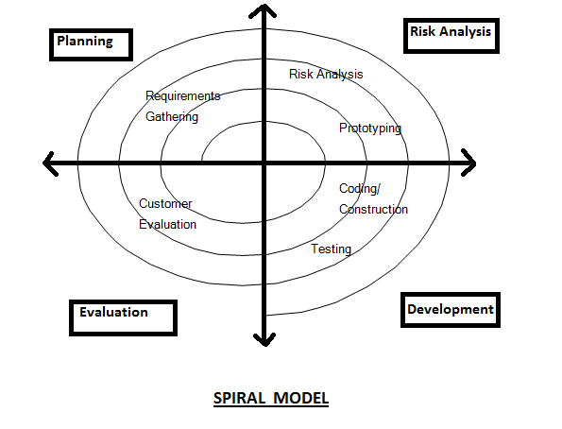

VU Process Model:
Vu process model is the combination of waterfall and spiral model. We choose the vu process model because it is the combination of waterfall and spiral model which maximizes the quality of system and minimizes the risks and disadvantages.

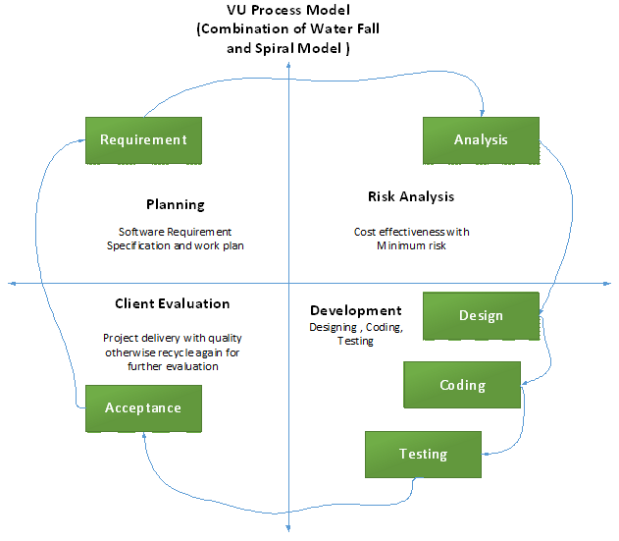

Reasons for choosing the Methodology
VU process was chosen model for the following reasons
- Waterfall methodology is simplest of all methodologies but it had following drawbacks

- Waterfall methodology is strictly sequential which does not allow any development out of sequence which is not good for this project
- In waterfall testing of software is not easy as the next iteration is only started after fully completing the last iteration.
- If some changes are to be made in the software in some later stages it is virtually impossible in waterfall methodology
- Agile model is only for small and team work projects so it was not an option

- Spiral model which is an extension of waterfall model is the right model. For added simplicity the original waterfall model is mix with it
- With this model
- In this model a starting design is available which could be developed further
- Prototype can be developed on which, strengths and weaknesses of the design could be tested
- In future prototypes, previous builds can be evolved.
- Inclusion of waterfall model will keep it simple enough.
- Testing is possible with prototypes.
- More than one prototype can be built at a time.
Final system will be built on the best prototype

- Work Plan

